

**Project Deliverable 1 – Project Proposal**

**Faculty Name:** Information Technology

**Module Code:** ITECA3-12

**Module Name:** Web Development and e-Commerce

**Content Writer:** Marc Kishinkwa

**Copy Editor:** Mr Kyle Keens

**Submission Date:** 28 February 2025

|  |  |
| --- | --- |
| **Student Name** | Thoriso Dibatana |
| **Student Number** | EDUV4841116 |
| **Project Title** | Garden To Table |
| **Submission Date** | 28 February 2025 |

**Table of Contents**

1.1 Introduction 2

1.2 Needs/Problems 3

1.3 Goals/Objectives 3

1.4 Procedures/Scope of Work 4

1.5 Timetable 4

Overall Gantt chart: 5

Deliverable 1 Gantt chart: 5

Deliverable 2 Gantt chart: 6

Deliverable 3 Gantt chart: 7

1.6 Conclusion 8

1.7 References 8

# Introduction

E-Commerce is an abbreviation for electronic commerce which is the process of buying and selling goods and services over the internet through websites, apps or online marketplaces. E-Commerce occurs in many forms, mainly business-to-business (B2B), business-to-customer (B2C), customer-to-customer (C2C) (Hayes, Downie, 2024). C2C is e-commerce where transactions are between individual buyers and sellers without the need for intermediaries (Ruttell, 2018). An example of C2C is Facebook Marketplace and Gumtree where individuals sell products or services directly to customers using the online platform.

Statista’s Digital Market Outlook estimates that 11.7 million e-commerce users will be registered in South Africa in 2025, and this figure is expected to increase to 21.52 million by 2029 (Cowling, 2025). E-commerce transactions in South Africa are expected to increase by 150% to a value of R225 billions by 2025 (Thenga, 2020). These figures are exceptional, but they are curbed by the high cost of data and limited access to fibre technology across the country.

Garden To Table is a community-centric C2C e-commerce platform designed to facilitate the trade of fresh produce among local community members. The platform is primarily targeted at lower-income individuals and township residents who seek affordable, quality, and nutritious food while supporting local entrepreneurship. Garden To Table enables community members who have surplus produce or unused garden space to generate income by selling their goods to nearby buyers. By encouraging local trade, the platform aims to minimize transportation costs and promote sustainability.

# Needs/Problems

The rising cost of living and food insecurity have made it increasingly difficult for lower-income households to access fresh and nutritious food. Small-scale and subsistence farmers also lack a structured, formal marketplace to sell their surplus produce efficiently. Unemployment is a large contributing factor towards poverty. Problems and needs that Garden To Table aims to address include:

* The lack of accessible, affordable fresh produce for township residents.
* Limited income opportunities for individuals with unused garden space or surplus crops.
* High transportation costs associated with traditional food distribution networks.
* Absence of a structured, user-friendly platform that connects local buyers and sellers of fresh produce in the township.
* Tackle unemployment and poverty.

# Goals/Objectives

Goals and objectives that Garden To Table aims to achieve are:

* Provide a digital marketplace where community members can trade fresh produce easily. Doing this will encourage local trade and empower the local economy in the township.
* Cultivate financial empowerment and entrepreneurship by enabling small-scale farmers and home gardeners to monetize surplus goods.
* Reduce food waste by facilitating trade of excess produce.
* Encourage local sustainability by minimizing transportation needs and fostering community connections. Minimizing transportation cost will ultimately means people will pay less on their food.

# Procedures/Scope of Work

* **Wireframes and UI designs:** Designs the basic UI of the pages of the website using wireframes and a wireframing application/tools.
* **Database design:** Design the database and show the data to be stored and the relationship between different elements.
* **Platform development**: Build the website using HTML, CSS, JavaScript, PHP and Bootstrap. Create the database using MySQL and XAMP to establish the database connection. Use Git for version control and GitHub for a remote, online repository.
* **Internal testing and integration:** Test the website and database along with the connection on localhost.
* **Hosting and beta testing:** Host and deploy the website using GitHub pages and test it with real world users in a controlled environment.
* **User registration & listings**: Allow sellers to create accounts, list their available produce, and set prices.

# Timetable

|  |  |  |
| --- | --- | --- |
|  | **Description of Work** | **Start and End Dates** |
| **Deliverable 1** | Project proposal. Research on C2C Ecommerce. | Start: 10 February 2025  End: 28 February 2025 |
| **Deliverable 2** | Documentation and code. Prototype design. | Start: 01 March 2025  End: 30 May 2025 |
| **Deliverable 3** | User manual presentation. Formal presentation. | Start: 6 June 2025  End: 13 June 2025 |

Gantt charts (Stratvert, 2023)

## **Overall Gantt chart:**

|  |  |  |  |  |
| --- | --- | --- | --- | --- |
| **Garden To Table: Overall Gantt Chart** | | | | |
|  |  |  |  |  |
| **Tasks** | **Start Date** | **Days Needed** | **Completion** | **Adjusted Length** |
| Deliverable 1 | 10-Feb-2025 | 14 | 28-Feb-2025 | 18 |
| Deliverable 2 | 1-Mar-2025 | 65 | 30-May-2025 | 90 |
| Deliverable 3 | 6-Jun-2025 | 5 | 13-Jun-2025 | 7 |

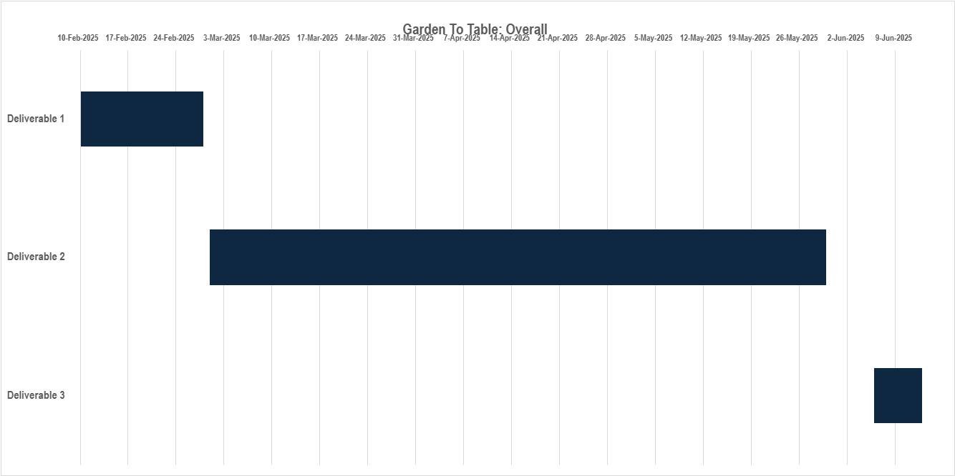

## Deliverable 1 Gantt chart:

|  |  |  |  |  |
| --- | --- | --- | --- | --- |
| **Garden To Table: Deliverable 1** | | | | |
|  |  |  |  |  |
| **Tasks** | **Start Date** | **Days Needed** | **Completion** | **Adjusted Length** |
| Planning, Timetable, Gantt Chart | 10-Feb-2025 | 2 | 12-Feb-2025 | 2 |
| Research | 12-Feb-2025 | 4 | 18-Feb-2025 | 6 |
| Ideation | 10-Feb-2025 | 7 | 19-Feb-2025 | 9 |
| Project proposal draft | 18-Feb-2025 | 5 | 25-Feb-2025 | 7 |
| Project proposal writing | 25-Feb-2025 | 3 | 28-Feb-2025 | 3 |
| Submission | 28-Feb-2025 | 0 | 28-Feb-2025 | 1 |

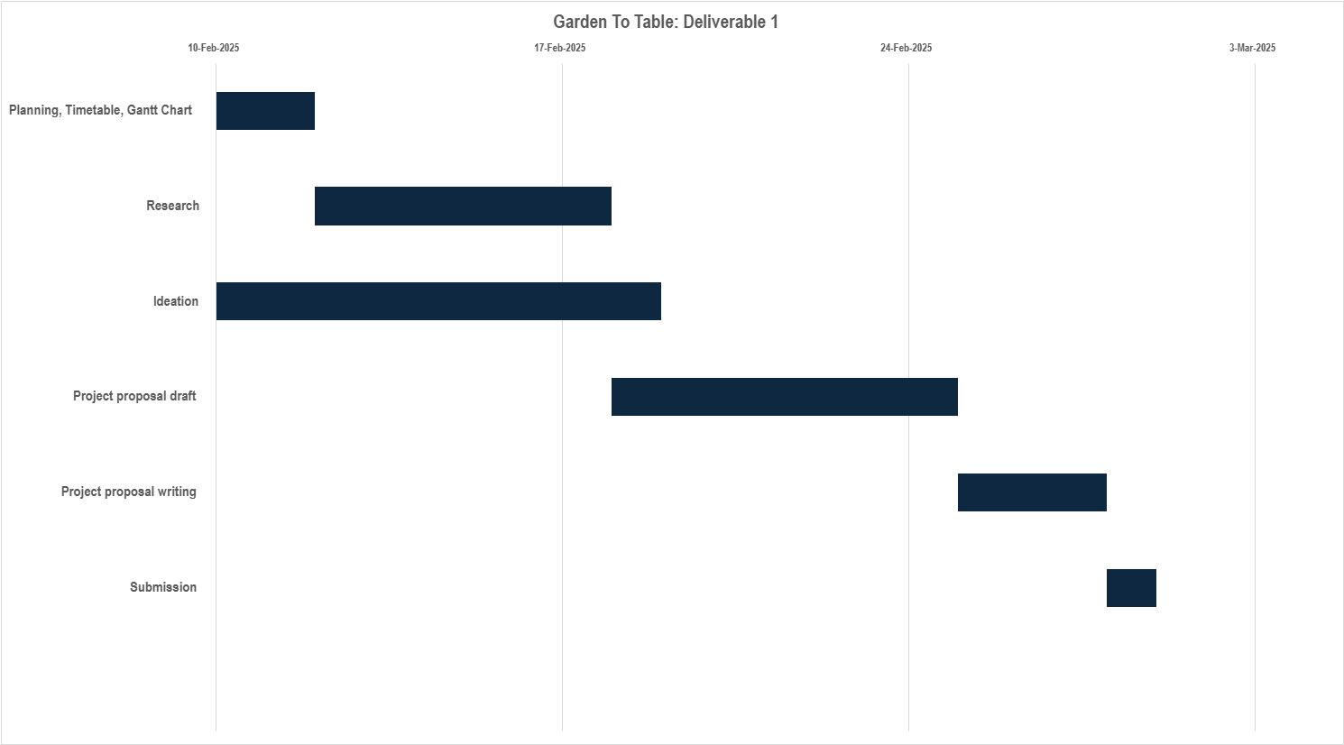

## Deliverable 2 Gantt chart:

|  |  |  |  |  |
| --- | --- | --- | --- | --- |
| **Garden To Table: Deliverable 2** | | | | |
|  |  |  |  |  |
| **Tasks** | **Start Date** | **Days Needed** | **Completion** | **Adjusted Length** |
| Wireframe and UI design | 1-Mar-2025 | 7 | 11-Mar-2025 | 10 |
| Database design | 11-Mar-2025 | 7 | 20-Mar-2025 | 9 |
| Platform development | 20-Mar-2025 | 30 | 1-May-2025 | 42 |
| Internal testing and integration | 1-May-2025 | 7 | 12-May-2025 | 11 |
| Hosting and beat testing | 12-May-2025 | 7 | 21-May-2025 | 9 |
| User registration and listing | 21-May-2025 | 7 | 30-May-2025 | 9 |

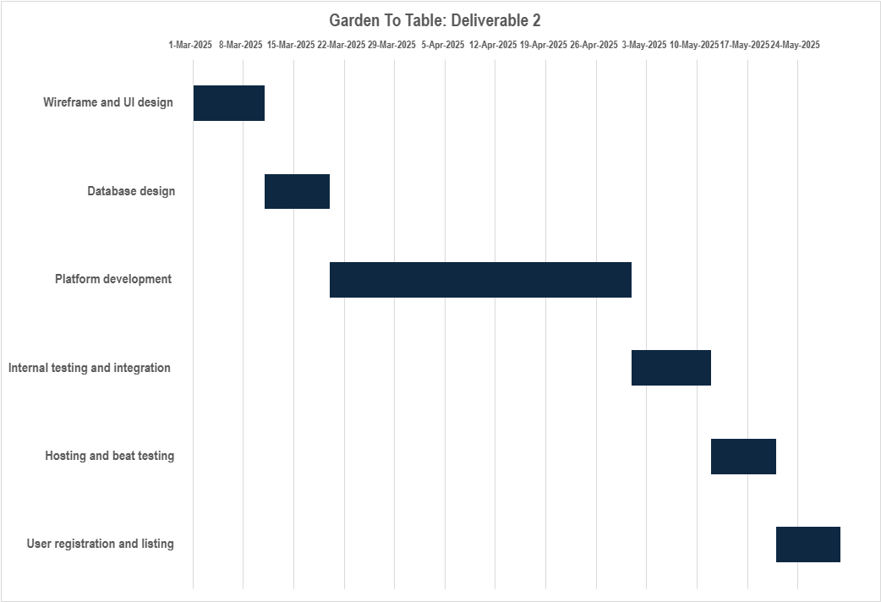

## Deliverable 3 Gantt chart:

|  |  |  |  |  |
| --- | --- | --- | --- | --- |
| **Garden To Table: Deliverable 3** | | | | |
|  |  |  |  |  |
| **Tasks** | **Start Date** | **Days Needed** | **Completion** | **Adjusted Length** |
| Write user manual | 6-Jun-2025 | 2 | 10-Jun-2025 | 4 |
| Presentation powerpoint and preparation | 6-Jun-2025 | 4 | 12-Jun-2025 | 6 |
| Presentation | 12-Jun-2025 | 1 | 13-Jun-2025 | 1 |

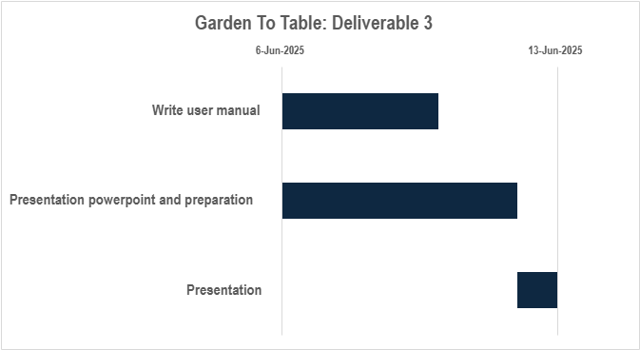

# Conclusion

Garden To Table aims to be more than just an e-commerce platform. It is a community initiative aimed at addressing food accessibility, unemployment and financial empowerment through entrepreneurship at the grassroots level. By creating a seamless marketplace where fresh produce can be traded locally, the platform will not only provide affordable food options but also support small-scale entrepreneurship. With a structured development plan, Garden To Table has the potential to scale and transform community-driven commerce in townships and beyond.

# References

1. Laudon, K. and Traver, C. 2020. E-Commerce 2020-2021: Business. Technology and Society, Global Edition, 16th Edition. Pearson UK, ISBN-13: 9781292343167
2. Nixon, R. 2021. Learning PHP, MySQL & JavaScript: With jQuery, CSS & HTML5. 6th edition. O’Reilly Media, Inc., ISBN: 9781492093824
3. Build full Ecommerce website using HTML, CSS, JavaScript, Tech2 etc [Youtube], 20 December 2021, Available at: <https://youtube.com/playlist?list=PL9bD98LkBR7P8MYh0RzNSHgeVNTA8g0nB&si=0tMkD2UgKFsUPRGE> [Accessed: 14 February 2025]
4. Login & Register Web Form using PHP XAMPP Frontend, Backend & Database Connection, Frank Tech [Youtube], 10 March 2024, Available at: <https://youtu.be/rHs0b2MaNpg?si=nwWdM_2_QqF-3KPk> [Accessed: 14 February 2025]
5. Host website on github for free in just 2 mins, AKRITI GOSWAMI [Youtube], 17 September 2023, Available at: <https://youtu.be/BT4WzyT2g8k?si=JUDL5RYRHHMOki2I> [Accessed: 14 February 2025]
6. Hayes, M., Downie, A., 2024, What is ecommerce, IBM, 29 February 2024, [Online] Available at: <https://www.ibm.com/think/topics/ecommerce,> [Accessed 15 February 2025]
7. Ruttell, G., 2018, *Buyers’ institution-based trust in South African C2C e-commerce: a social capital theory perspective* [Online]. [Accessed: 16 February 2025]
8. Cowling, N., 2025, E-commerce in South Africa - statistics & facts, Statista, 3 January 2025, [Online] Available at: <https://www.statista.com/topics/11038/e-commerce-in-south-africa/#topFacts> [Accessed: 22 February 2025]
9. Thenga, A., 2020, E-commerce to be worth R225bn in SA in 5 years as expectations change, 16 September 2020, [Online] Available at: <https://www.rmb.co.za/news/ecommerce-to-be-worth-r225bn-in-sa-in-5-years,> [Accessed: 22 February 2025]
10. How to Make Gantt Chart in Excel, Kevin Stratvert [Youtube] ,28 July 2023, Available at: <https://youtu.be/zC22yPmc6Kw?si=AsUBTC1XCUifub2c> [Accessed: 23 February 2025]
11. Tsotesi, N. 2023, *Factors Influencing Consumer Purchase Intentions: A Study of E-Commerce Platforms in South Africa*. [Online]. [Accessed: 26 February 2025]
12. Mayayise. 2023, T.O., *Investigating factors influencing trust in C2C e-commerce environments: A systematic literature review* [Online]. [Accessed: 26 February 2025]
13. How to Properly Layout A Website (For Beginners), The Website Architect [Youtube], 9 April 2022, Available at: <https://youtu.be/3C_22eBWpjg?si=uZ3yyjjspF-lRKfY> [Accessed: 28 February 2025]
14. The Best Homepage Layout In Web Design (Supported by UX), The Website Architect [Youtube], 21 March 2021, Available at: <https://youtu.be/g0db5kA4BfQ?si=DvgbpnWU7T5wGjvC> [Accessed: 28 February 2025]
15. Responsive Web Layout Using HTML CSS & Bootstrap 5, Divinector [Youtube], 27 February 2025, Available at: <https://youtu.be/CrSBYhLpN7Q?si=GFmygMxPDQi4yqxQ> [Accessed: 28 February 2025]